

**Example Mouth Care Policy for Paediatric Inpatients**

**Contents**

1. Document Statement ........................................................................................................................
2. Key Points .....................................................................................................................................
3. Definitions ......................................................................................................................................
4. Oral physiology...................................................................................................................................
5. Compromised Oral Well Being…………………………………………………………...……………....
6. Duties………………………………………………………………………………………………………....
7. Policy details……………………………………………………………………………………………..….
8. Procedure ...................................................................................................................................
9. Performing oral care
   1. The Mini Mouth Care Matters Mascot

9.2 Performing oral care in a child or young person where there is no compromise to carrying out regular oral care...................................................................................

* 1. Performing oral care in a child or young person where there is some compromise to the ability to carry out regular oral care………………………………………….…………..
     1. Swallowing difficulties
     2. Dry, sore and cracked lips
     3. Furred or coated tongue
     4. Plaque or debris on teeth
     5. Immunocompromised child or young person with cancer
     6. Children who are intubated
     7. Patients who are nil by mouth

1. Neonatal patients…………………………………………………………………………………………...
2. Orthodontic appliances ……………………………………………………………………...…………….

12. Dealing with soreness .....................................................................................................................

13. Dealing with dry mouth ...................................................................................................................

14. Frequency of mouth care………………………………………………………………….......………..…

15. Mouth care chart…………………………………………………………………………………...…….…

16. Training needs………………………………………………………………………………………..…….

17. Review process ..............................................................................................................................

18. Equality Impact Assessment (EQIA) ………………………………..……………………………...……

19. Process for monitoring compliance…………………………………………………………………...…..

20. References………………………………………………………..………………………………………....

Appendix 1 Mouth Care Instructions ……………...…………………………………..……

Appendix 2 Mouth Care Chart and recording tool …………..……………………………………….

Appendix 3 The Mini Mouth Care Matters Elephant Mascot

Appendix 4 The SMILE poster

**1 Document Statement**

Good oral health is essential for a person’s health, dignity, hygiene, comfort and quality of life. It maintains the person’s ability to communicate, to enjoy food and drink, and to develop. When oral hygiene is neglected the mouth can become dry and sore, the tongue and roof of mouth becomes coated and stained all of which can cause complications as well as distress. It can also lead to a major source of infection if the dentition develops caries, leading to poor general health outcomes and in some cases lead to significant delay of more serious treatments such as transplants and chemotherapy.

Mini Mouth Care Matters is an initiative set up in response to the lack of oral health care provided for in-patient paediatric patients. It addresses lack of training and awareness, and aims to empower all medical professionals to “lift the lip” and inspect the oral cavity as well as aid the patient in maintaining their oral hygiene whilst in hospital, with a view to continue good oral health practices at home.

Mouth Care should be part of the daily care delivered to patients to prevent any potential sources of infection, and reduce the number of complications attributed to poor oral hygiene and tooth decay. It is a basic personal hygiene need that should not be neglected.

There is evidence that hospitalisation is associated with a deterioration in oral health of patients (Terezakis et al., 2011). This in turn has been linked to:

* An increase in hospital-acquired infections
* Poor nutritional intake
* Longer hospital stays - Poor oral health is strongly associated with malnutrition and this in turn can affect a patient’s recovery (Gil-Montoya et al., 2008), increasing time in hospital.
* Increased care costs

The principal objective of oral care is to maintain the mouth in a good condition. More specifically it aims to:

* Keep the oral mucosa and lips clean, soft, moist and intact
* Remove, and prevent the build-up of food debris/dental plaque without damaging the gingiva
* Alleviate pain/discomfort
* Prevent halitosis and freshen the mouth
* Maintain oral function
* Decrease the risk of oral and systemic infection
* Increase general well-being

# 2 Key Points

* Assessment of each individual’s needs upon admission, and re-assessment at appropriate intervals
* Planning and frequency of mouth care
* Ability to “lift the lip” and identify any urgent problems
* Dignity and privacy of patient
* Encouraging all patients to register with their local dental practice or dental community service
* Promote key oral health messages as promoted by the British Society of Paediatric Dentistry
* Seeking advice from a dental professional when necessary

***Remember maintaining good oral hygiene is essential to improved health outcomes and improved quality of life***

**3 Definitions**

Oral health is defined as: ‘A standard of health of the oral and related tissues which enables an individual to eat, speak and socialise without active disease or embarrassment and which contributes to general wellbeing’ (Department of Health, 1994).

Dougherty and Lister (2008) states that good oral hygiene will help to minimise complications related to taste changes, infection, foul odour, bleeding and pain. This is turn will facilitate patient comfort.

Glossary of terms:

|  |  |
| --- | --- |
| **Mouth Care**  **Mini Mouth Care Matters (Mini MCM)** | Is in reference to care in all the structures within the oral cavity. This includes the soft and hard tissues (cheeks, tongue, gums, hard and soft palate, lips, teeth)  Refers to the project funded by Health Education England, providing the training, oral health care policy and mouth care assessment tools to assist Trusts in their development of mouth care routines and local policies |
| **Family** | Rather than “next of kin” has been used throughout this policy |
| **Dental Plaque** | A sticky biofilm of micro-organisms that adhere to surfaces in the mouth |
| **Calculus/Tartar** | Calcified plaque that adheres to teeth; needs professional removal by a dentist or dental hygienist |
| **Gingivitis** | Inflammation of the gingiva (gums). Gums can look red and swollen, and may bleed during brushing |
| **Caries** | Tooth decay |
|  |  |
| **Halitosis** | Bad breath |

|  |  |
| --- | --- |
| **Candidiasis/Thrush** | Fungal infection caused by candida fungus present in the natural flora of the mouth appears as white curd like deposits on soft tissues |
| **Ulcers** | A breach in the epithelium exposing underlying connective tissue |
| **Herpes Simplex** | Cold sores |
| **Xerostomia** | Dry mouth |

**4 Oral Physiology**

The oral cavity is the first part of the alimentary tract. The structures visible on examination are:

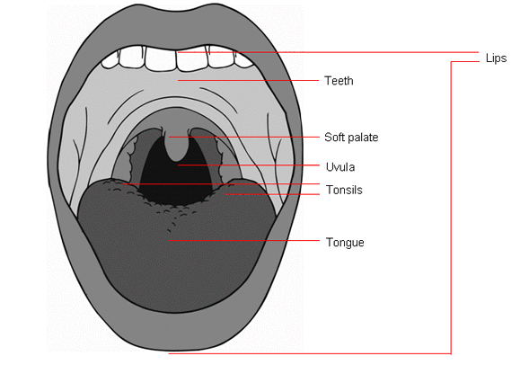

**The mucosal lining and saliva**

The oral cavity is lined throughout with mucous membranes consisting of stratified squamous epithelium, which contain small mucus-secreting glands. Saliva is the combined secretions from the salivary glands and the small mucus-secreting glands of the lining of the oral cavity. Saliva consists of water, mineral salts, enzyme (salivary amylase), mucus, lysozyme, immunoglobulins and blood clotting factors.

The functions of saliva are:

* Chemical digestion of polysaccharides by the enzyme amylase
* Lubrication of food so that it is ready to be swallowed
* Cleansing and lubricating the mouth, keeping the tissues soft, moist and pliable. It also helps prevent damage to the mucous membranes from rough and abrasive foods
* Lysozymes, immunoglobulins and clotting factors help combat invading microbes
* The taste buds are stimulated only by substances in solution. Dry foods once mixed with saliva are then able to stimulate the sense of taste (McErlean, 2016)

**The lips**

These form a muscular entrance to the mouth. They are covered by squamous, keratinized epithelial tissue, which is vascular and very sensitive. They are necessary for ingestion of food, enunciation of words and are involved in conveying the mood of a person via facial expressions e.g. smiling and grimacing.

**The tongue**

This is covered with stratified squamous epithelium for protection, from which project numerous papillae and taste buds on the upper surface. The tongue plays an important part in mastication (chewing), deglutition (swallowing), speech and taste (McErlean, 2016).

**The teeth**

Although the shape of teeth varies, the structure is the same and consists of:

* The crown – protrudes from the gum
* The root – embedded in the bone

The interior of the tooth consists of a pulp cavity that contains the blood vessels, lymph tissue and nerves. Surrounding the pulp cavity is a hard substance called dentine. Outside the dentine of the crown is a thin layer, the enamel. This is a very hard substance. The root of the tooth is covered with a substance that resembles bone, called cementum. This fixes the tooth into its socket. The functions of the teeth include biting off pieces of food, grinding and chewing food, and social functions such as smiling (McErlean, 2016).

The first tooth normally erupts around six months of age, with the full complement of 20 deciduous (temporary or milk) teeth being acquired by the age of 24 months. Permanent dentition begins in the sixth year of age, with 32 teeth usually present by the 24th year (McErlean, 2016).

## 5 Compromised oral well-being

Pain and soreness in the mouth can cause an aversive reaction to food and eating, therefore the aim should be to minimise these ill effects. Younger children, due to their age and development, require assistance with carrying out oral hygiene routinely, in addition children and young people with many conditions may have compromised oral well-being.

#### **General and medical conditions that can compromise oral well-being include (list not exhaustive):**

* ***Fever:*** may lead to a dry mouth and coated tongue.
* ***Grinding of the teeth*** may result in loss of tooth surface.
* ***Thumb/finger sucking*** can alter the position of teeth.
* ***Poor nutritional intake:*** anorexia, dehydration, metabolic disorders (requiring high intake of oral carbohydrates) and some types of glycoprotein storage disease, can result in vitamin deficiency, tissue vulnerability, an increase in dental caries and oral ulceration.
* ***Cerebral palsy, craniofacial surgery, stroke, trauma and other illnesses***: can lead to neurological impairment, unconsciousness, loss of a limb, maxillofacial injury which may lead to difficulty or inability to perform oral hygiene independently and require assistance from others.
* ***Children with respiratory problems and/or an enlarged or protruding tongue:*** may be mouth breathers and consequently can experience dry mucosa with an increased risk of mucosal deterioration.
* ***Restricted movement of the tongue*** due to surgery or pain may lead to the body’s usual removal of debris being ineffective.
* ***Chronic constipation:*** may cause a foul mouth and odour.
* ***Down’s syndrome*** has a spectrum of presentations and severity which can impact on the oral health of children or young people.  They may have underdevelopment of the bones in their face, along with an enlargement of their tongue, and the growth and development of teeth may be affected.  They may also have a tendency towards thick, ropy, sticky saliva, which adheres to the surface of the teeth and lacks the natural cleansing properties of normal saliva.  Any number of these may lead to a change in oral health, in particular dry mouth, and cracked lips which may cause discomfort ([Shore et al, 2010](https://www.gosh.nhs.uk/health-professionals/clinical-guidelines/mouth-care#References)).
* ***Cleft lip and palate:*** children with cleft lip and palate can have more tooth decay than the general population. This means extra attention should be given to highlighting prevention, especially reducing sugar in the diet and performing effective tooth brushing. Referral to a paediatric dentist is recommended for these patients.
* ***Cancer/Bone Marrow Transplant:*** Mucositis and ulceration causing pain, infection and bleeding can arise in children and young people receiving chemotherapy or radiotherapy (specifically to their head or neck). See under cytotoxic agents for further information and definition of mucositis.
* ***Immunodeficiencies:*** Children and young people with immunodeficiencies such as acquired immune deficiency syndrome (AIDS), severe combined immune deficiency (SCID) or following treatment for cancer, may experience persistent candida infections and be at risk of bacteraemia/septicaemia. They may also have reduced production of protective immunoglobulins in their saliva resulting in an increased risk of infection.

***Medications and treatments*** that can compromise oral well-being include (list not exhaustive):

**Antibiotics:** may alter the child or young person's oral and gut flora and increase the risk of opportunistic infections such as candida albicans (which can lead to oral thrush). Tetracyclines may cause staining of the teeth from yellow to brown.

**Chlorhexidine-based mouthwash:** may result in temporary brown staining of teeth, a stinging or burning sensation or a bitter taste/altered after taste ([British National Formulary for Children (BNFC), 2016](https://www.gosh.nhs.uk/health-professionals/clinical-guidelines/mouth-care#References)).

**Corticosteroids:** Corticosteroids can lead to delayed healing of tissue, gum hyperplasia, altered taste perception (often metallic) and absent or ropy saliva. Inhaled corticosteroids used for the treatment of asthma can increase the risk of candidiasis occurring ([BNFC, 2016](https://www.gosh.nhs.uk/health-professionals/clinical-guidelines/mouth-care#References)).

**Cytotoxic agents:**A common side effect of cytotoxic agents is mucositis, a painful inflammation and ulceration of the mucous membrane ([Bennett, 2016](https://www.gosh.nhs.uk/health-professionals/clinical-guidelines/mouth-care#References)). Detailed information about mucositis in children and young people receiving cancer therapy can be found in the [Mouth Care for Children and Young People with Cancer: evidence-based guidelines](http://www.rcpch.ac.uk/sites/default/files/asset_library/Research/Clinical%20Effectiveness/Endorsed%20guidelines/Mouth%20Care%20for%20CYP%20with%20cancer%20(cancer%20study%20group/mouth_care_cyp_cancer_guidelinev2.pdf) ([UKCCSG-PONF Mouth Care Group, 2006](https://www.gosh.nhs.uk/health-professionals/clinical-guidelines/mouth-care#References)).

***Mucositis*** is a toxic inflammatory reaction that can affect the entire gastro intestinal tract from the mouth to the anus, in response to receiving cytotoxic therapy or radiation. Symptoms can include: inflammation; dry mouth; ulceration of mucosa, overproduction of saliva: gingiva and the palate; dry, cracked and bleeding lips ([McCulloch et al, 2013](https://www.gosh.nhs.uk/health-professionals/clinical-guidelines/mouth-care#References)).

The terms mucositis and stomatitis are often used interchangeably. There are, however, some general distinctions, whereas mucositis described above is a reaction to cytotoxic therapy or radiotherapy. Stomatitis refers to any inflammatory reaction affecting the oral mucosa, with or without ulceration ([Eilers et al 2014](https://www.gosh.nhs.uk/health-professionals/clinical-guidelines/mouth-care" \l "References)).

* **Iron supplements:** can cause temporary green/black staining of teeth
* **High sucrose-content medications:** can lead to an increased incidence of dental caries
* **Nifedipine:** can lead to gingival enlargement ([BNFC, 2016](https://www.gosh.nhs.uk/health-professionals/clinical-guidelines/mouth-care#References))
* **Phenytoin and cyclosporine:** either can cause enlarged gingiva ([BNFC, 2016](https://www.gosh.nhs.uk/health-professionals/clinical-guidelines/mouth-care#References))

**Dry mouth:**Anticholinergics; Antihistamines; Atropine; Opioid analgesics; Oxygen therapy; Radiotherapy to the head and neck; Tricyclic antidepressants ([BNFC, 2016](https://www.gosh.nhs.uk/health-professionals/clinical-guidelines/mouth-care#References)).

# 6 Duties

Mouth care is the responsibility of ALL health care professionals caring for patients in the Trust.

Staff will be supported to promote good oral health and up to date evidence based oral care education will be provided for nursing staff by the Mini MCM programme.

A product information leaflet is available in the resources section of the Mouth Care Matters website <http://www.mouthcarematters.hee.nhs.uk/> and can be referred to for recommended products and tools for oral health. This will routinely be updated, so please refer to website.

There is much evidence that shows mouth care is frequently neglected or not a priority for hospitalised patients. A study of hospitalised patients by Sousa et al., (2014) found that patients’ oral health was not being assessed and that hospitals had no policies in place for routine oral health practices. It has also been shown that there is no standardisation in the delivery of oral care and that a lack of equipment, such as toothbrushes and toothpaste, means that nurses are sometimes improvising with forceps and gauze (Stout, Goulding and Powell, 2009).

# 7 Policy Details

Promoting good oral health and hygiene, and identifying changes by “lifting the lip” and inspecting the oral cavity are essential elements of nursing practice. This will include evaluating and documenting care using the training and materials Mini MCM has provided.

Good oral care in hospitalised patients will improve not only the patient’s oral health and prevent oral pain and infection, but will also impact on a patient’s overall health and wellbeing. Locker et al. (2002) have shown that in medically compromised patients, oral health problems significantly affect their wellbeing and quality of life.

Nurses and allied healthcare professionals have a duty of care to carry out and record appropriate assessments whilst considering the individual patient needs. This assessment will include planning, reviewing, evaluating and documenting care. Common nursing barriers to providing or assisting patients with mouth care in hospital have been researched (Adams, 1996; Preston et al., 2006). These include:

* Lack of knowledge
* Lack of training
* Lack of time
* Lack of equipment
* Lack of oral assessment tools
* A disagreeable attitude towards mouth care
* Attitude towards own dental health

## 8 Procedure

## Assessment of the oral cavity (Appendix 1)

To enable appropriate mouth care to be implemented, a thorough oral assessment is required. The oral assessment represents the vital first step in planning effective oral care ([Gibson et al 2006](https://www.gosh.nhs.uk/health-professionals/clinical-guidelines/mouth-care#References)). The assessment procedure should be explained to the child or young person and family, including why the assessment is necessary and what it entails.

Whenever possible the child or young person should be involved in the assessment.

Where possible, when assessing the mouth of a young child, it is advisable to have a second adult present to support the child's head.

A good source of light is required to examine the oral cavity.

Hand hygiene should be performed and an apron and non-sterile gloves worn.

Staff undertaking assessment of the oral cavity should be trained in the use of the mouth care assessment and recording tool. Nursing staff or healthcare support workers may be best placed to perform regular assessment of a child or young person’s oral status.

An effective oral assessment should involve the following aspects of the mouth:

* Teeth and oral hygiene
* Lips, tongue, gums and saliva
* & how a patient responds to having their teeth brushed

Conditions that compromise oral well-being (risk factors) should also be considered when undertaking an oral assessment.

It is important to accurately record the assessment in the child or young person’s health care record and on the mouth care assessment and recording tool sheet. (Appendix 2)  
Anyone who has had the appropriate training can carry out a basic oral assessment. MiniMCM is NOT there to diagnose specific oral or dental conditions.

###### **Teeth and oral hygiene**

Observe the appearance of the teeth using a pen torch to illuminate the oral cavity. The teeth should be clean with no debris present. Observe for the presence of plaque or debris in localised areas, or generalised along the gum margin. If the child has no teeth, this should also be recorded. Look carefully at the teeth for any discoloured areas, especially brown staining, or holes in the teeth as this is normally a sign of tooth decay and requires treatment. Look out for any areas of swellings associated with decayed/rotten teeth.

###### **Lips, tongue, gums and saliva**

Observe the appearance of the lips. They should be smooth, pink and moist. Check for any dryness, cracks, ulceration and bleeding.

Observe the appearance of the tongue using a pen torch to illuminate the oral cavity. The tongue should be pink and moist with papillae present. Check tongue for loss of papillae with a shiny appearance, fissures (cracking or splitting), presence of oral candida, redness, ulceration and sloughing (with or without bleeding).

The mucous membranes should be pink and moist. Observe for any redness or coating without ulceration, and/or oral Candida. Also observe for any ulceration or sloughing, with or without bleeding.

The gingiva should be pink or coral with a stippled (dotted) surface. The gum margins should be tight and well defined, with no swelling. Observe for the presence of oedema with/without redness, smooth gingivae, or spontaneous bleeding.

Observe the consistency and quality of saliva. Saliva should be thin and watery. Check for excess amount of saliva and drooling (excessive saliva may be present if child is teething). Observe for thick, ropy or absent saliva.

## 9 Performing oral care: preparation and assistance

The nurse/health care assistant role is to facilitate family-centred care, therefore, whenever possible oral care should be performed by the child or young person and/or the family member/carer. Whenever possible, encourage the child or young person to take control of their mouth care.

Play specialists (where available) can help prepare children and young people for oral care.

The child or young person should be encouraged to handle the mouth care equipment and products in a non-threatening environment, and perform mouth care on a favourite toy, a parent/carer or nurse. Ensure explanations are age appropriate and reinforced with written information where available.

The child or young person’s need for privacy must be respected when undertaking any aspect of oral care.

Older children and/or teenagers may have increased concerns regarding body image. Involve this age group in planning their oral care so that they will understand its importance.

The level of assistance for mouth care required by the patient should be assessed on an individual basis and not assumed.

***9.1 The Mini Mouth Care Matters Elephant Mascot (Appendix 3)***

The Mini MCM Elephant Mascot has been developed as an aide memoire for staff to be aware of the level of assistance needed for adequate oral health care to be provided for the patient, based on their individual needs. It is a discreet method of identifying those patients who may require additional help in their oral health care, and as a reminder to ask patients daily, ‘have you brushed your teeth today?”

The Mini MCM Mascot should be placed alongside the patient’s bed, depending on the needs of that patient.

**Independent/parental assistance patients**



Independent patients are defined as those that can look after their mouths on their own. They can be classed as independent if they can get out of their bed, walk to the bathroom and brush their teeth without assistance. Those patients with a parent/carer who need some assistance (aged under 7 years), but mouth care being provided by the family should have the **Single Elephant** **Mini MCM Mascot** placed near the bedside.

**Some staff assistance/fully dependent patients**



Patients who are fully dependent on another person for mouth care include children who are very young, unconscious, or have severe physical or learning disabilities. Patients may have compromised manual dexterity, or a learning difficulty who may require reminding to brush their teeth. For this group of patients, the **Double Elephant Mini MCM Mascot** should be placed near the patient’s bedside to indicate that this patient requires help to maintain good oral health.

**NB** Please remember to ask your patients twice a day if they have had their teeth cleaned, and record this on the daily recording sheet. Parents/carers are also encouraged to record all mouth care they give on the recording sheet.

**ALL MOUTH CARE IS TO BE RECORDED EACH TIME IT IS GIVEN**

#### **9.2 Performing oral care in a child or young person where there is no compromise to carrying out regular oral care:**

Dental hygiene should begin as soon as primary teeth erupt, ([DH 2017](https://www.gosh.nhs.uk/health-professionals/clinical-guidelines/mouth-care#References)).

The child or young person’s mouth should be assessed and appropriate mouth care given. The assessment should be carried out upon admission using the mouth care assessment and recording tool (inpatients with a stay of more than 24 hours). This should be repeated weekly, unless there is a change in medical status (e.g. has undergone surgery)- in which case the assessment should be more frequent.

Children should be helped or supervised by an adult when brushing their teeth, until at least seven years of age.

Normal practice/routine from home may be continued if appropriate.

A small headed toothbrush with a handle which is comfortable should be used to brush/clean teeth ([DH 2017](https://www.gosh.nhs.uk/health-professionals/clinical-guidelines/mouth-care#References)).

Brushing should occur twice daily for a minimum of two minutes, last thing at night before bed and at least one other time each day ([DH 2017](https://www.gosh.nhs.uk/health-professionals/clinical-guidelines/mouth-care#References)).

Brushing last thing at night allows the fluoride levels to remain high, as salivary flow rates are reduced during sleep.

Toothpaste should be spat out and the mouth should **NOT** be rinsed with water or mouthwash after brushing teeth.

**Prior to performing oral care, the nurse should:**

* put on an apron
* perform a social hand wash (refer to hand hygiene guideline)
* put on a pair of non-sterile, powder and latex-free gloves

#### **Cleaning a younger child's teeth**

To clean a younger child's teeth, it may be easier to stand or sit behind them, and cradle their chin in your hand. This will allow you to reach the top and bottom teeth more easily ([Oral Health Foundation, 2017](https://www.gosh.nhs.uk/health-professionals/clinical-guidelines/mouth-care#References)).

Use a smear of toothpaste (no less than 1,000 ppm fluoride) for a child less than three years. Use a pea-sized amount of toothpaste for a child greater than three years of age (with more than 1,000ppm fluoride), unless advised otherwise by the child’s dentist ([DH 2017](https://www.gosh.nhs.uk/health-professionals/clinical-guidelines/mouth-care#References)).

Encourage them to spit out excess toothpaste and not rinse with water. Rinsing with water reduces the caries-preventative effect of the fluoride toothpaste ([DH 2017](https://www.gosh.nhs.uk/health-professionals/clinical-guidelines/mouth-care#References)). Do not allow the child to eat the toothpaste.

Use small circular movements when cleaning the teeth and try to brush each surface of every tooth, brush behind the teeth, onto the gums and your tongue ([Oral Health Foundation 2017](https://www.gosh.nhs.uk/health-professionals/clinical-guidelines/mouth-care#References)).

For more information on tooth brushing refer to the [Oral Health Foundation website](https://www.dentalhealth.org/tell-me-about/topic/childrens-teeth/childrens-teeth).

Soft paraffin ointment if used should be used sparingly and applied using a gloved finger if necessary. Each container of soft paraffin ointment is for single patient use. Use with caution in children and young people receiving oxygen therapy due to the flammable nature of soft paraffin.

#### **9.3 Performing oral care in a child or young person where there is some compromise to the ability to carry out regular oral care.**

###### **Swallowing difficulties**

If a child or young person has been assessed as having swallowing difficulties:

* Use a soft, small headed toothbrush and fluoride toothpaste to gently brush gums and teeth, starting on the outside of the teeth then on the inner cheek and move from back to front (this helps to prevents patients gagging).

***Seek advice from speech therapists***

* Be aware that’s patients with swallow/dysphagia problems are at more risk of choking and aspiration, and are at high risk of aspiration pneumonia therefore mouth care is of the utmost importance.

###### Consider using a:

###### non-foaming/non-flavoured toothpaste

* + toothbrush with active suction from a colleague- a specially designed toothbrush with in-built suction mechanism will minimise risk of aspiration for patients with dysphagia

###### **Dry, cracked or ulcerated lips**

* Water based gels are preferable; Vasaline (petroleum jelly) and K.Y. gel are also useful. Patients on radiotherapy should avoid all oil based products. Care to be taken with patients who are on oxygen and use of paraffin ointment

## Furred or coated tongue

*Especially present in patients who are nil by mouth*

* If the tongue is coated or furred use damp gauze, moutheze or small headed toothbrush gently to help remove. This may take a few days to have effect. Use suction as appropriate
* Use a fluoride toothpaste if needed
* If not possible use wet gauze as appropriate to wipe the surface of the tongue
* Food debris and hardened mucus can be removed by moistening these areas with warm water, then use suction and tweezers can be used to dislodge the debris

###### **Plaque or debris on teeth**

* Commence health education as and when appropriate
* Record progress of improvement of oral hygiene on recording tool at daily assessment of oral cavity
* May need to brush more frequently if thick layer of plaque/debris that is not amenable to removal in one attempt

###### **Immunocompromised child or young person with cancer**

* Brush their teeth twice daily, using fluoride toothpaste and a soft toothbrush
* Dispose of brush at regular intervals as suggested by guideline below during active treatment

For more information about mouth care for this patient group, please read [the Mouth care for Children and Young People with Cancer: Evidence-based guidelines](http://www.cclg.org.uk/write/MediaUploads/Member%20area/Treatment%20guidelines/Mouth_Care_at_a_Glance.pdf) ([UKCCSG-PONF Mouth Care Group 2006](https://www.gosh.nhs.uk/health-professionals/clinical-guidelines/mouth-care#References)).

###### **Children or young people who are intubated**

Patients who are intubated should not have their oral care forgotten, and their needs should be assessed on an individual basis. They should receive regular oral care as part of the care offered to prevent Ventilator Assisted Pneumonia as part of the Department of Health’s High Impact Interventions ([DH, 2007](https://www.gosh.nhs.uk/health-professionals/clinical-guidelines/mouth-care#References)). Local policies and documentation should be followed.

Care must be taken if the patient is intubated orally that the endotracheal tube is not misplaced whilst carrying out oral care.

**Patients who are nil by mouth**

These patients need more frequent mouth care, use damp gauze to keep secretions down to a minimum and remove dried deposits.

Tooth brushing is important for patients who are nil by mouth to keep the mouth clean and healthy and to prevent the development of dental calculus/ tartar. Patients may still be taking oral “tasters” which could carry a cariogenic risk the teeth. In any case, it is advised to maintain oral health care and if there are any anticipated problems with aspiration, please use a suction toothbrush or modify technique.

1. **Neonatal patients**

Aims of mouth care for this patient group are the same as for any paediatric in-patient. For the sick or preterm neonate who is not yet receiving regular oral feeds, it also aims to:

* Provide a positive oral experience for the infant
* Support early sensory development of taste and smell
* If unable to swallow, to encourage absorption of colostrum through the oral mucosa

**Performing mouth care for the neonate**

* Clean hands
* Using a gauze swab, dip it into a bottle of sterile water and remove any excess water
* Wipe the baby’s lips to remove any dry skin or debris
* Dispose of swab, and use another clean swab if needed
* If the baby’s lips are dry apply a thin layer of soft paraffin (Vaseline) or liquid paraffin directly to the lips using a cotton tipped applicator or your finger tip
* Discard all used items, and wash hands
* Be aware of how the baby’s lips, tongue and mouth appear, and monitor if at any time they become/appear dry, sore, swollen, red, cracked or bleeding. Manage as appropriate and involve medical team if necessary

## Orthodontic Appliances

*For patients with fixed appliances (train tracks);*

* Clean above the brace at the gum line with a soft-headed brush and between the brackets with a single tufted brush.
* Apply orthodontic wax if any part of the brace is rubbing or causing an ulcer.
* If the brace is loose or broken, advise the patient to see their orthodontist as soon as reasonably possible.

*For patients with removable appliances (e.g.retainers);*

* Brush the teeth, gums and soft tissues with toothbrush.
* Clean the appliance using toothbrush and water. To be stored in an orthodontic box when not in use.
* If the retainer is very loose or broken, advise the patient to see their orthodontist as soon as reasonably possible.

## 12 Dealing with soreness

Try to assess the reason for soreness: broken teeth, mucositis, candidiasis, angular cheilitis (non-healing cracks at the corner of the lips).

Ulceration, if in doubt get the patient checked by a medical/dental professional. **Any ulcer consistently present for 2 weeks must be referred to a medical/dental professional as a matter of urgency.**

## 13 Dealing with dry mouth

This can be very distressing, preventing patients from eating, speaking and swallowing properly. Again maintain high standards of oral hygiene, use frequent sips of cold or tepid water.

In palliative care; patient’s drugs, dehydration, poor oral intake and oxygen without humidification, can all contribute to dryness.

Use the same guidelines but introduce lubricating gels as per product list on HEE website for MiniMCM. Dry mouth gels should be applied onto the affected areas (can use a Moutheze stick) and rubbed into the area gently. This can be repeated at two hourly intervals if necessary. Dry mouth gels can also be used to soften hardened secretions to enable them to be removed without causing discomfort.

## 14 Frequency of care

This will always be determined by the patient’s condition, therefore careful assessment is essential. Unless prescribed otherwise mouth care should be carried out **at least** twice a day.

**15 Mouth Care Chart**

Complete the Mini mouth care recording chart at least twice a day and keep in patients notes. A copy of the chart is available in appendix *** of this policy.

The latest version of the chart can be found on <http://www.mouthcarematters.hee.nhs.uk/>

(please refer to website for the most up to date version)

# 16 Training Needs

All relevant staff will be made aware of this policy as part of their training with Mini MCM. Mouth care leads should be aware of this policy and disseminate to their appropriate areas. It may be modified per the needs of the department, and any local policies/practice that may be in place.

Nursing staff and End of Life Volunteers should receive the necessary training and education in mouth care as part of their training programme.

# 17 Review process

This document will be reviewed within three years from the date of ratification. In order that this document remains current, any of the appendices to the policy can be amended and approved during the lifetime of the document without the document strategy having to return to the ratifying committee.

**18 Equality Impact Assessment (EQIA)**

**\*\***An equality impact assessment (EqIA) is a process designed to ensure that a policy, project or scheme does not discriminate against any disadvantaged or vulnerable people**

# 19 Process for monitoring compliance

Following 6 months of implementation of this policy a mouth care audit will be carried out and the results and feedback will be given to NMF and other relevant department managers.

**References**

* *Adams, R. (1996) Qualified nurses lack adequate knowledge related to oral health, resulting in inadequate oral care of patients on medical wards. Journal of Advanced Nursing; 24 : 552-560*
* *Adult Dental Health Survey (ADHS), 2009 – The NHS information Centre, March 2011*
* *Bedford NHS Hospital Trust: Mouth care protocol 2017*
* *DOH Oral health definition (1994)*
* *Dougherty, L. & Lister, S. (2008). The Royal Marsden Hospital Manual of Clinical Procedures: Student Edition. Oxford. Wiley-Blackwell*
* *Gil-Montoya, J.A. Subirá, C., Ramón, J.M. GonzálezMoles, M.A. 2008. Oral Health- Related Quality of Life and Nutritional Status. American Association of Public Health Dentistry. 68(2), pp. 88-93*
* *Gloucester Hospital NHS Foundation Trust Mouth care guide lines 2015*
* *Locker, D., Matear, D., Stephens, M., Jokovic, A. (2002) Oral health-related quality of life of a population of medically compromised elderly people. Community Dental Health; 19 (2): 90-97*
* *NICE CKS Palliative care 2017*
* *NHS Borders Mouth care policy 2017*
* *NHS Wales mouth care guidelines 2012*
* *NMC (2015)*
* *Preston, A.J. Punekar, S., Gosney, M.A. (2000) Oral care of elderly patients: nurses’ knowledge and views. Postgraduate Medical Journal; 76 (892): 89-91*
* *Scottish palliative care guidelines 2017*
* *Severn Hospice Mouth care chart for specialist palliative care setting*
* *Sousa, L.L.A., Silva Filho, W.L.S.e., Mendes, R.F., Moita Neto, J.M., Prado Junior, R.R. (2014) Oral health of patients under short hospitalization period: observational study. J Clin Periodontol; doi:10.1111/jcpe.12250.*
* *Stout, M., Goulding, O., Powell, A. (2009) Developing and implementing an oral care policy and assessment tool. Nursing Standard; 23 : 42-48.*
* *Terezakis, E., Needleman, I., Kumar, N., Moles, D., Agudo, E. (2011) The impact of hospitalization on oral health: a systematic review. Journal of Clinical Periodontology; 38 (7): 628-636.*

**Appendix 1: Mouth Care Instructions**

**Assess your patient for understanding, ability and compliance**

**If the patient is able to continue with their own oral hygiene routine, then encourage this:**

**Talk to your patient**

* Let them know what you are doing and why

# Assess your patient

**Risk Assess - If possible and appropriate explore by:**

* Using gauze dampened with water
* If safe and appropriate to do so sweep around the insides of the cheeks to explore the mouth

• Let the patient become accustomed to this

# IF IN DOUBT SEEK PROFESSIONAL DENTAL ADVICE

***Carry out mouth care at least twice a day, unless prescribed otherwise***

***Ensure mouth care given is recorded appropriately***

# Have your mouth care equipment ready

* Good source of light (pen torch)
* Face mask / PPE
* Small headed toothbrush: ***order code ILA4097*** *(To be stored upright to air dry)*
* Toothpaste, if appropriate and palatable to patient (select toothpaste as per patient needs)
* Gauze
* Tweezers
* Suction as required
* Plastic cup, warm water

# Supplementary equipment

* Moutheze: **order code ILA901**.To be stored upright to air dry, do not leave to soak. Reuse for up to a week
* Chlorhexidine gluconate (alcohol free mouthwash)

# Appendix 2: Mouth Care Assessment and Recording form

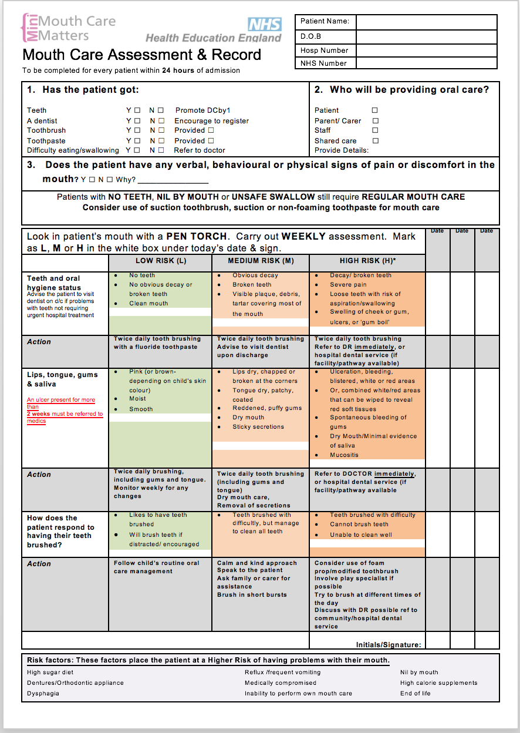

# 

**Appendix 3: The Mini Mouth Care Matters Elephant Mascot**

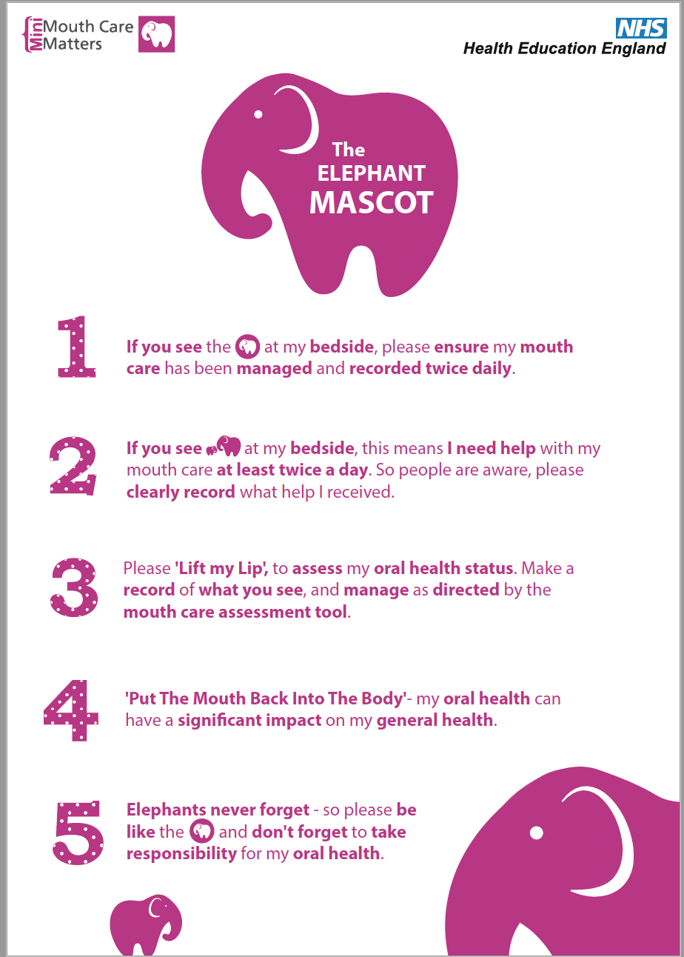

**Appendix 4: The SMILE poster- An acronym designed to help remember the FIVE key points for carrying out good mouth care**

